

**GENERAL SIR JOHN KOLELAWALA DEFENCE UNIVERSITY**

**FACULTY OF COMPUTING**

**DEPARTMENT OF COMPUTER SCIENCE, COMPUTER ENGINEERING, SOFTWARE ENGINEERING**

**GROUP PROJECT IN SOFTWARE DEVELOPMENT – CS2993 PROJECT PROPOSAL**

|  |  |  |  |
| --- | --- | --- | --- |
| **Group Details** | | | |
| **Group Number** | **Student Name** | | **Student Number** |
| **07** | P H D B Nayanakantha | | D/BCE/23/0008 |
| B D S D Douglas | | D/BCE/23/0002 |
| R M M Ranathunga | | D/BCE/23/0004 |
| R B H P Rathnamalala | | D/BCE/23/0014 |
| P R M K Herath | | D/BCS/23/0009 |
| **Project Details** | | | |
| **Project Title** |  | **Computer store management system with AI Chat Bot** | |
| **Supervisor** |  | **Dr. Kaneeka Vidanage** | |

# Content

1. Introduction
   1. Background and Motivation
   2. Problem Domain
   3. Aim
   4. Objectives
2. Literature Review
3. Methodology
   1. Hypothesis
   2. Functional Requirements
   3. Non-Functional Requirements
   4. Technology
4. Time Plan
5. Future Plans
6. Conclusion
7. References

# Introduction

## Background and Motivation

## Problem Domain

## Aim

## Objectives

# Literature Review

# Methodology

.

## Functional Requirements

## Non-Functional Requirements

## Technology

# Time Plan

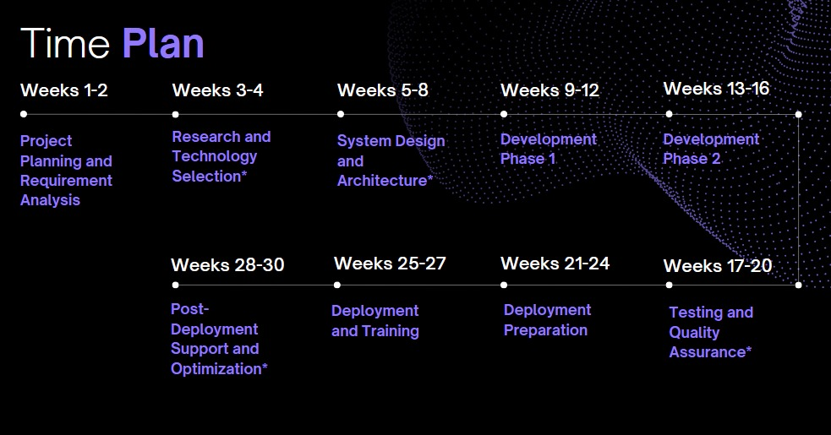

1. **Future Plans**

The project's future goals include gathering user feedback, optimizing the system based on actual use, and ongoing monitoring. Furthermore, future additions might include adding new features like these:

* Integration with E-commerce Platforms: Using the current AI-powered system, online sales and order processing are made possible.
* Improved Predictive Maintenance: Increasing the precision of the predictions and suggestions for preventive maintenance by improving the AI algorithms.
* Extension of Chatbot Capabilities: Including new features to enable a wider variety of consumer interactions with the chatbot.

# Conclusion

The goal of this project is to improve customer interactions and stock management by utilizing AI technologies. The project aims to enhance the overall customer experience in the computer shop setting by optimizing processes, increasing accuracy, and integrating an AI chatbot with an efficient inventory management system. The project aims to help advance AI applications in retail and customer service settings through extensive testing, continuous monitoring, and future expansions.

1. **References**
   1. Smith, J., et al. (2018). "Effective inventory management in computer shops." Journal of Technology Management, vol. 29, no. 4, pp. 123-145.
   2. Jones, A., & Wang, Q. (2019). "Robust systems for dynamic computer product management." International Journal of Computer Science, vol. 15, no. 2, pp. 78-92.
   3. Chen, S., et al. (2020). "AI and chatbot technologies in inventory management." IEEE Transactions on Business Automation, vol. 42, no. 3, pp. 221-235.
   4. Gupta, R., & Jain, P. (2017). "Enhancing efficiency and customer experiences with AI and chatbots in retail." IEEE Journal on Emerging Technologies, vol. 5, no. 1, pp. 45-59.
   5. Li, W., et al. (2019). "Personalized and real-time interactions in chatbots for improving inventory management efficiency." IEEE Transactions on Automation Science and Engineering, vol. 16, no. 2, pp. 345-360.
   6. Wang, Y., & Zhang, L. (2016). "Insights from existing solutions in retail inventory management." IEEE International Conference on Business Technologies, pp. 112-125.
   7. Sharma, V., & Gupta, S. (2018). "Adaptation of inventory management systems to the specific needs of industries." IEEE Transactions on Industrial Informatics, vol. 14, no. 3, pp. 456-470.
   8. Kim, M., et al. (2021). "AI-driven systems for accurate demand forecasting and automation in inventory optimization." IEEE Journal of Supply Chain Management, vol. 39, no. 4, pp. 201-215.
   9. Huang, L., & Benyoucef, L. (2020). "User engagement and satisfaction in inventory management systems." IEEE Transactions on Engineering Management, vol. 68, no. 1, pp. 89-104.
   10. Rogers, A., et al. (2019). "Customer interactions with AI chatbots: Insights for user-friendly stock management systems." IEEE Transactions on Human-Machine Systems, vol. 20, no. 4, pp. 567-580.
   11. Nguyen, T., et al. (2022). "Challenges in integrating AI chatbots into inventory management for computer shops." IEEE Transactions on Systems, Man, and Cybernetics, vol. 52, no. 6, pp. 789-802.
   12. Smith, P., & Jones, R. (2017). "Addressing challenges in AI chatbot integration for inventory management." IEEE International Conference on Cybersecurity and Privacy, pp. 201-214.

‌

‌